Ameen Almakrami

Lap# 4

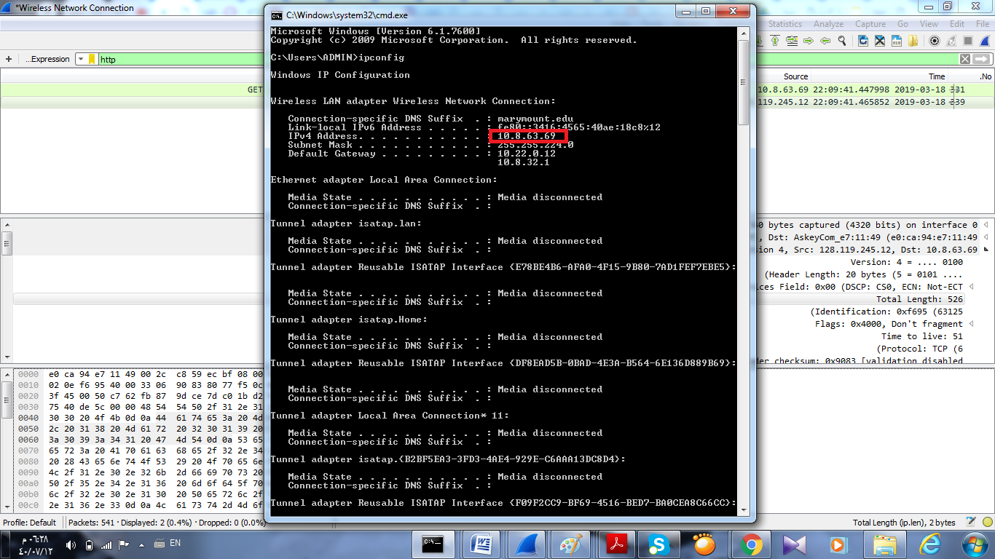

1. What is the IP address of your computer? – Wireshark screenshot not, Terminal

Answer is 10.8.63.69

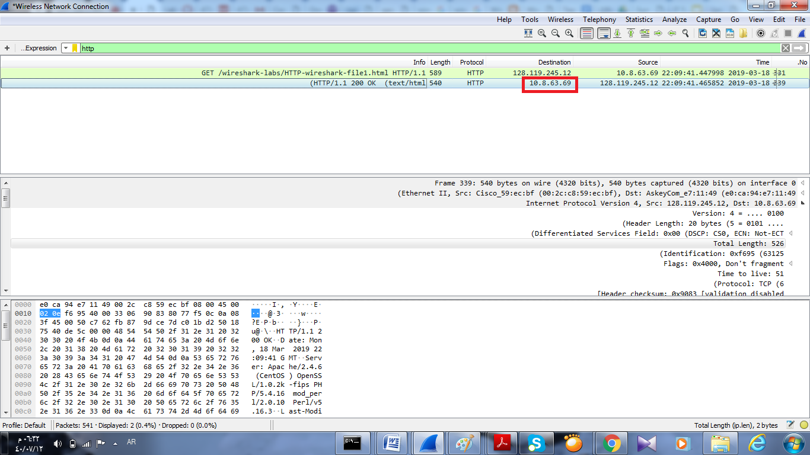

2. What is the total length of the datagram?

Answer is total length 526

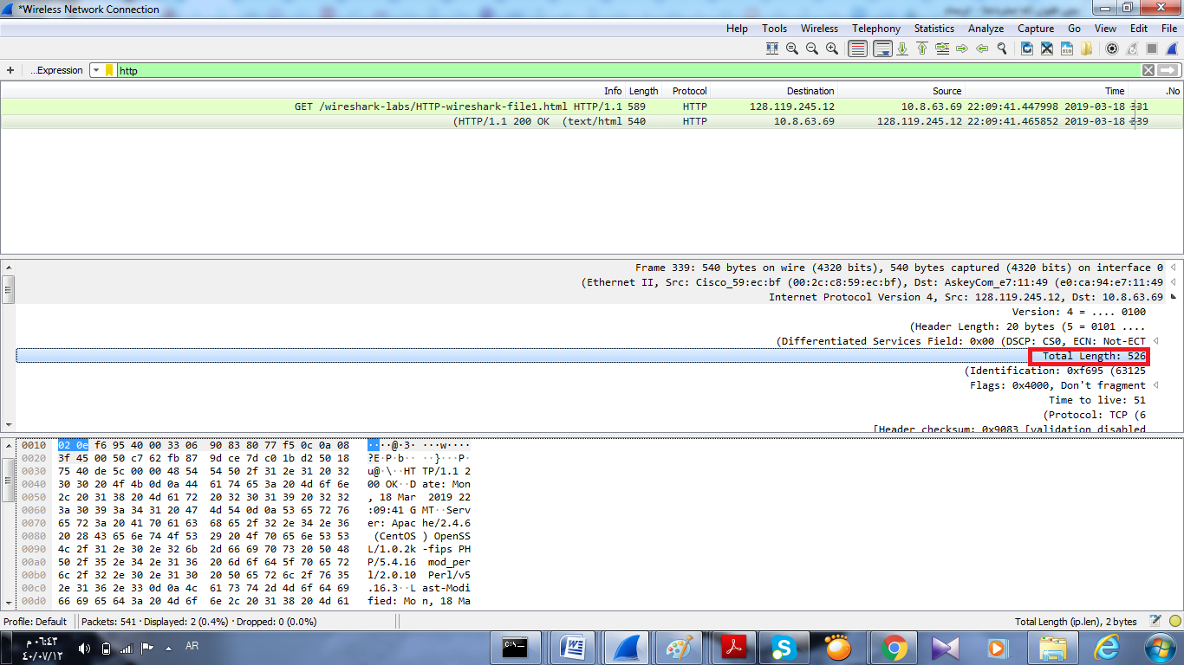

3. Has this IP datagram been fragmented?

Answer is do not fragment.

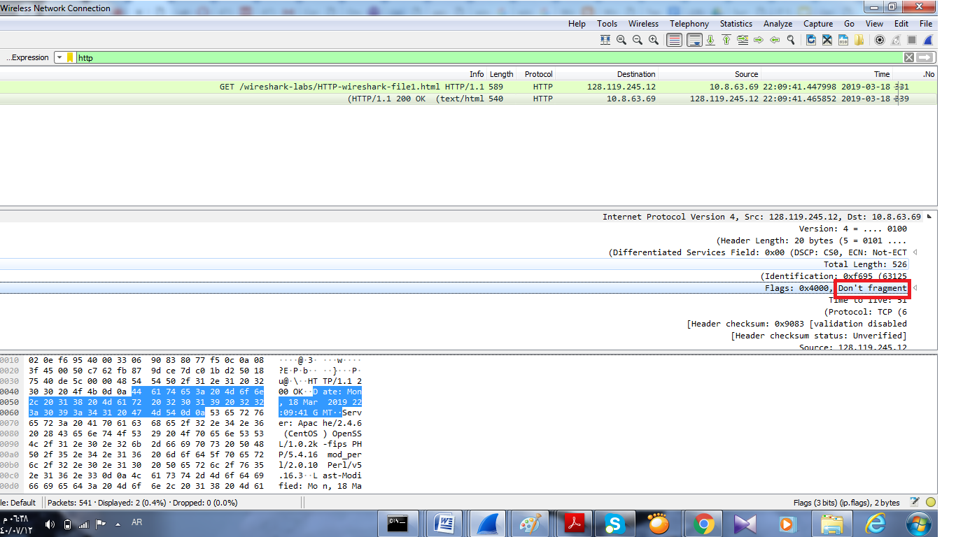

4. How many bytes are in the IP header?

Is 20 bytes answer

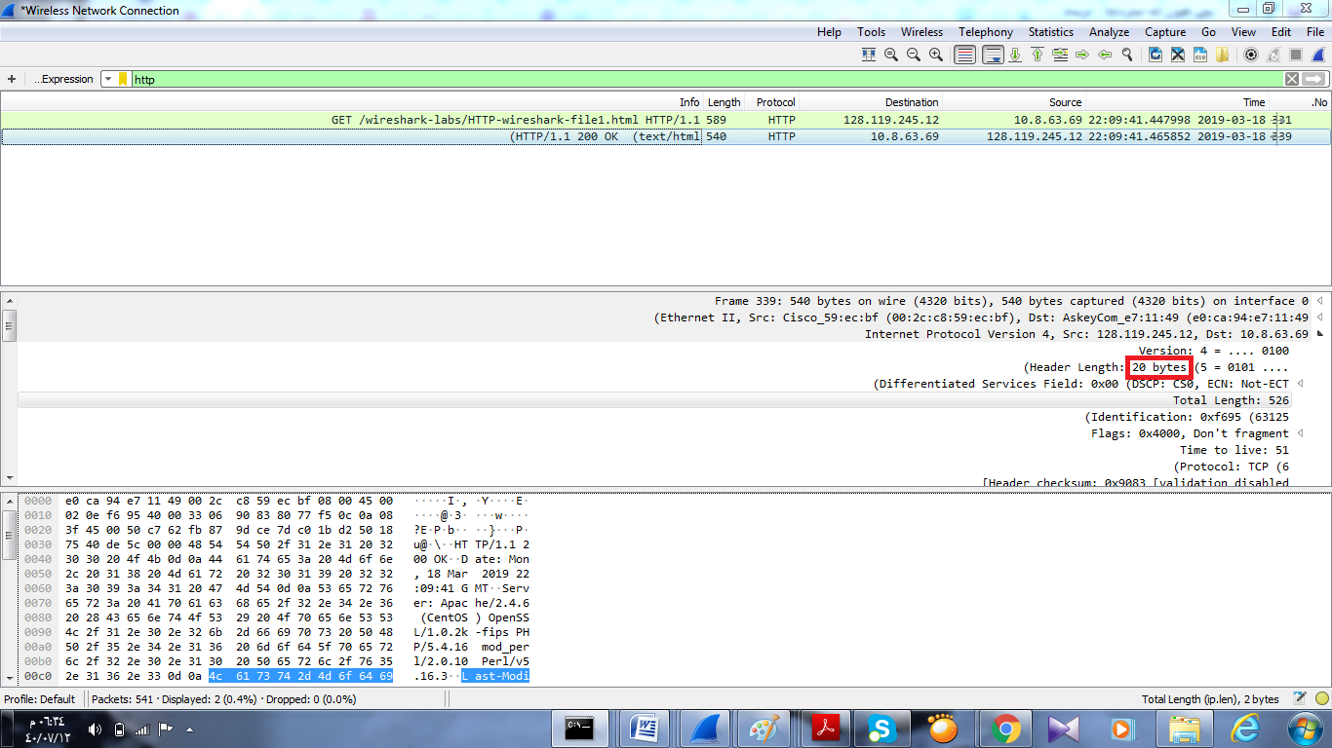

5. How many bytes are in the payload of the IP datagram? Explain how you determined the number of payload bytes.

Answer is total length –header length : 526-20=6

